Amazing Race: Pre-Colonial North America

1. Identifying Destinations
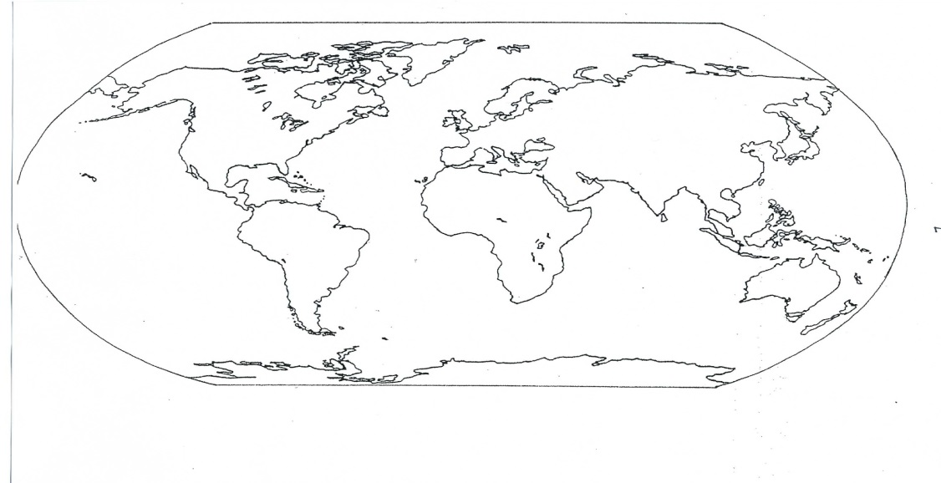
2
3
6
5
4
1
- Write the location number next to the correct statement.
Queen Elizabeth gave Sir Walter Raleigh permission to explore. What location on the map were they both from? |  | The Portuguese sailed, rounded __?__ and reached India. They were in control of this new sea route.
The spice trade with India and __?__ was extremely important and explorers were trying to find a shorter routed to avoid going around Africa. |  | Which body of water served as an early exploration highway for the European explorers and was the route Christopher Columbus sailed across to find a faster path to Asia?
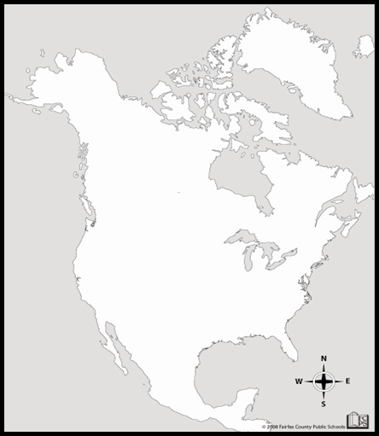

2. Explorers with Swag
Complete the table with the word bank terms.
~ Who Was I? Word Bank ~
-Wealthy man who financed the English Expeditions
- Spent weeks exploring Roanoke Island with Capt. Barlowe
-Artist who was governor of the Lost Colony
- Native American who visited England, learned English
- Led second expedition to Roanoke

Me | Who was I?
Sir Walter Raleigh
Ralph Lane
John White
Amadas

3. Motivation for Exploration
There are five motivators for explorers to travel. Use the images to help determine the reason. Write them on the lines below the images.

4. The Roanoke Voyages
Complete the table and write a summary of the accomplishments/results of each voyage.

Voyage | Year | Accomplishment / Results
_________ and ___________ | 1584
The ________ Lane Colony | 1585-1586
The _______ _________ Colony (Lost Colony) | 1587-1590

5. Explorers continued...
Fill in the blanks. (Use the word bank below)

The explorers brought the religion of _____________________ to the New World. The explorer named ______________ _______________ from ___________ made a historic voyage and sought another path to Asia, across the Atlantic. Explorers brought European _______________ causing many American Indians to get sick. _________ ____________ received a charter from Queen Elizabeth. He sent ________ and ___________ to explore and they returned to England with notebooks, plant samples, and two natives, _________ and __________. The second expedition to Roanoke was led by _________ _____________. He left with 107 men and 7 ships in the hopes of establishing a permanent settlement in Roanoke. Food was running out and the colonists were unhappy with Lane as governor because he was too militaristic. The colonists abandoned the colony and returned back to ____________.
WORD BANK:
-Spain -France - Islam Christianity
- Ralph Lane -Diseases -Christopher Columbus
- Weapons - England - Armadas - Barlowe
- Walter Raleigh - England - Manteo - Wanchese

6. The Lost Colony
Give 3 popular theories as to what may have happened to the lost colonists at the John White Colony at Roanoke in 1590?

1. | 2. | 3.

Before John White left, White asked the colonists to carve their destination into a tree if they needed to abandon their site. What symbol were they to carve if they were in danger? Please circle the correct answer.

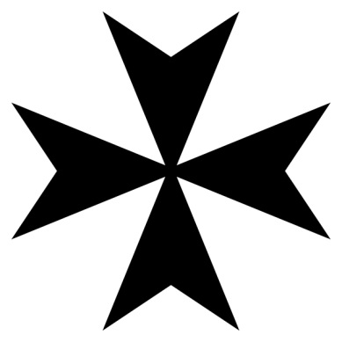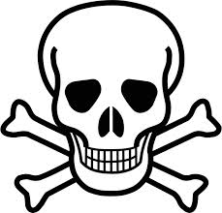

7. John White’s Paintings
Painting #1
- What is in this painting? _________________________________________________________________
- If I had to give this painting a title, it would be
___________________________________________________
- Two things I can INFER about this tribe based on this painting are:
1.______________________________________________________________________________________
2.______________________________________________________________________________________

Painting #2
- What is in this painting? _________________________________________________________________
- If I had to give this painting a title, it would be
___________________________________________________
- Two things I can INFER about this tribe based on this painting are:
1.______________________________________________________________________________________
2.______________________________________________________________________________________

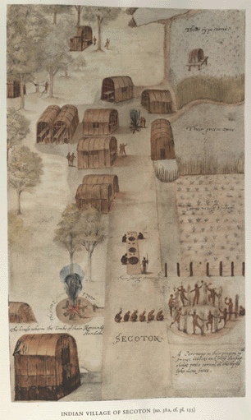
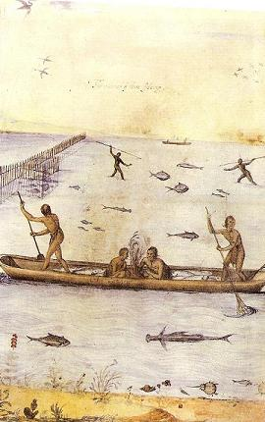
Painting #1 Painting #2

8. Vocabulary
Use the word bank to match the term with the correct description.
Word Bank
Charter | Geography | Colony
Columbian Exchange | Croatoan | New World

Description | Term
A name for the Americas, especially during the time of first exploration and colonization of the Americas by Europeans.
A group of people who leave their native country to form in a new land a settlement
The word John White found carved into a tree upon returning to the site of Roanoke Colony
Permission to go explore and eventually colonize the New World.
A widespread exchange of animals, plants, culture (including slaves), communicable diseases, and ideas between the Eastern and Western hemispheres.
The physical characteristics of an area.

