**Name: ____________________________________ Period: _____**

**The Great Depression: Analyzing Photographs**

|  |  |  |  |  |
| --- | --- | --- | --- | --- |
| **Photograph**  **#** | **1) What is happening in this picture?** | **2.) What problems or frustrations are suggested by this image?** | **3) What adaptations can you assume or infer people are making to these conditions?** | **4.) What help seems to be needed here? Prescribe a New Deal Program.** |
| **Photograph #_____** |  |  |  |  |
| **Photograph #_____** |  |  |  |  |
| **Photograph #_____** |  |  |  |  |
| **Photograph**  **#_____** |  |  |  |  |
| **Photograph**  **#______** |  |  |  |  |

1. What photograph impacted you the most? Why?
2. What do the photographs all have in common?
3. Can you learn about the Great Depression only through photographs? Does it tell the whole story? Explain.

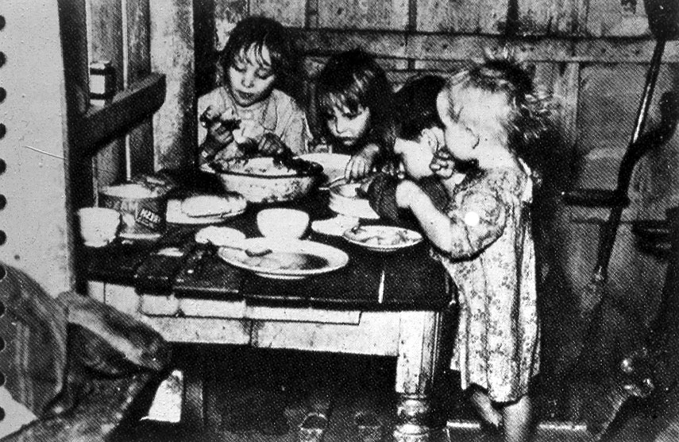

**Photograph #1**

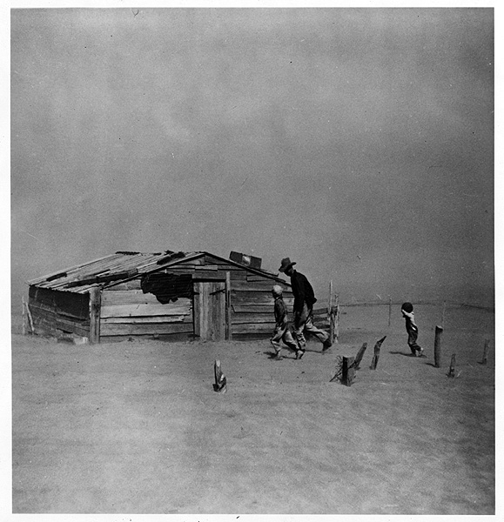

**Photograph #2**

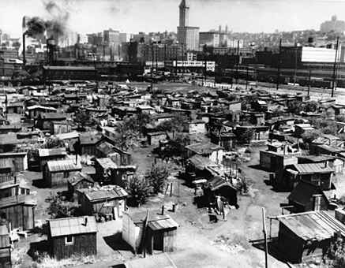

**Photograph #3**

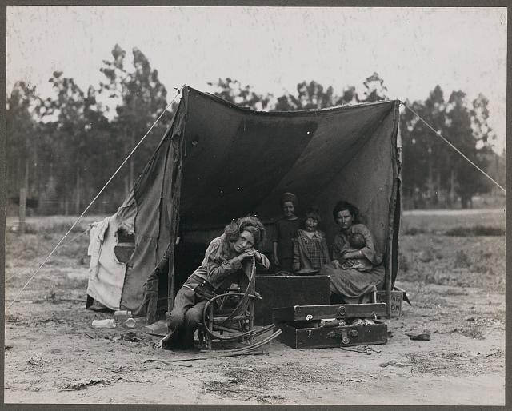

**Photograph #4**

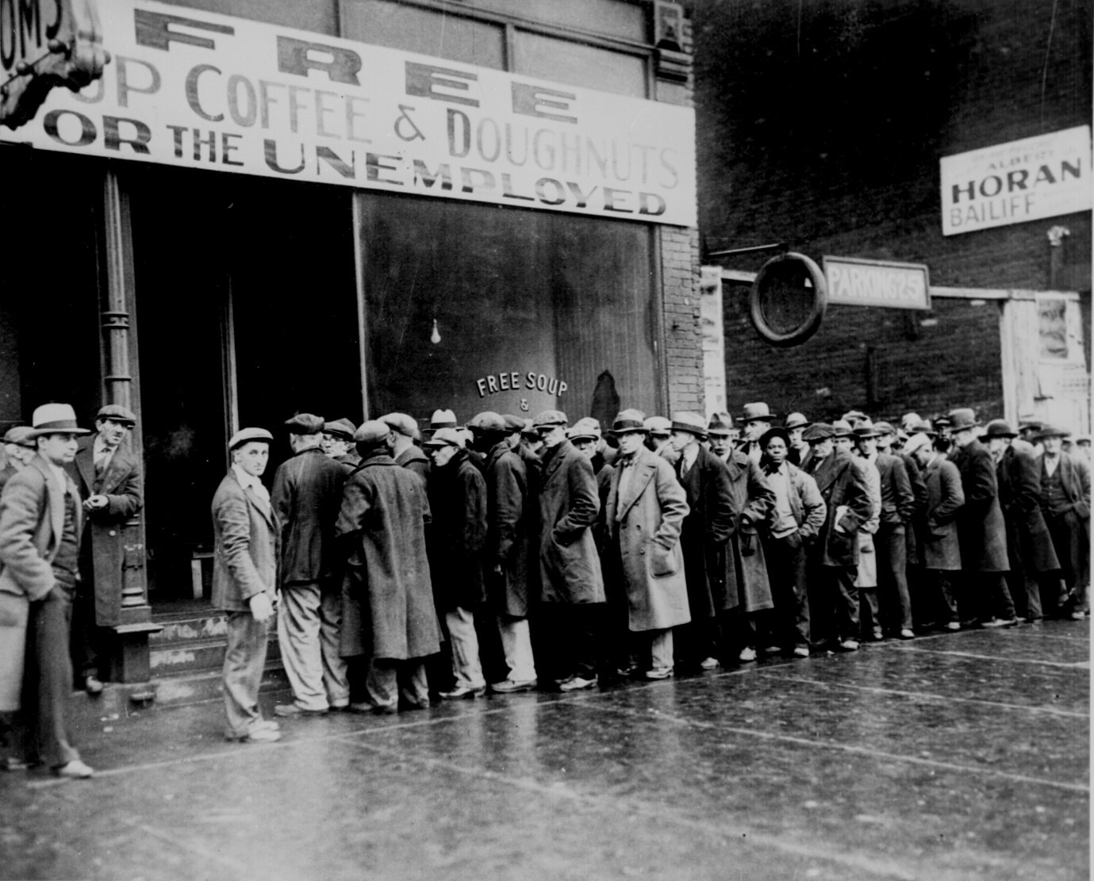

**Photograph #5**

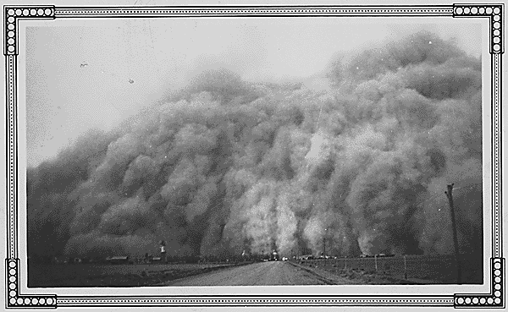

**Photograph #6**