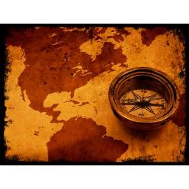
Why was there an age of Exploration?

The World Made New: Why the Age of Exploration Happened and How It Changed the World
Author: Marc Aronson

Causes
In 1491, Ferdinand and Isabella were driving to reclaim all of Spain from the Muslims. In the Andes Mountains of what is now South American, Inca Tupac Yupanqui was the glorious ruler of the Realm of the Four Quarters. AS the Christians drove towards the last Muslim stronghold in hot, dry southern Spain, and as the Inca tightened their hold over the high mountains, each expected the next year to bring familiar challenges. They were wrong.
If there is one date that stands out in all of human history it is 1492 – the first encounter between advanced civilizations that had developed an ocean apart. In that year Columbus crossed the Atlantic bringing about change on a scale not one person on earth could have imagined.
But why was it Columbus, a European, who set out on that voyage? And why did the peoples of the Americas respond to the strange newcomers as they did? In order to understand these questions, we first have to look at both sides of the ocean, just before they met.
The turning point that led to Columbus historic voyage actually took place in 1433. China had been sending one vast fleet after another out to ports in Asia and Africa. Guided by the able, seven-foot-tall admiral Zheng He, these were the largest, best boats in the world. Had the voyages continued, China would have been the master of the seas. But in 1433, the emperor of China decided that the trips were too expensive, and he stopped them.
That very same year, Gil Eannes, a Portuguese sailor, returned home in defeat. He announced that he could not sail past Cape Bojador, a terrifying point in Africa considered to be the end of the earth. His master, Prince Henry of Portugal, insisted that he try again. The following year Eannes succeeded. One ship after another followed him, until Portuguese ships rounded Africa and reached India. With Portugal in control of the new sea routes, Christopher Columbus sought another path to Asia, across the Atlantic.
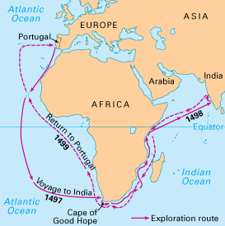

Columbus was not discouraged by the accomplishments of the Portuguese, just as Prince Henry refused to let Gil Eannes give in to his fears. Why were the Europeans so determined to voyage out into the unknown? They were hungry, but they did not lack food. Instead they treasured new knowledge. They were intensely competitive with each other. They craved wealth. They yearned for glory. And they felt a passion to spread their religion to the ends of the earth.

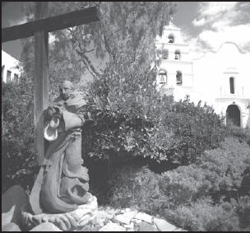
- Religion
After the death of Mohammed in 632, Muslims conquered much of North Africa and the Middle East. In 711, Muslims invaded Spain. There were periods in Spain when Jews, Muslims, and Christians lived in peace. But in 1095, Pope Urban II urged Christians to fight a holy war to win back the Holy Land. In the 1400s Spanish Christians began their own crusade to purify Spain. On January 2, 1492, Granada, the last Muslim kingdom, fell to the Christian armies. All Jews were soon expelled. As Columbus set sail, believes in the most battled-hardened form of Christianity were flush with their recent victories and eager for new crusades.
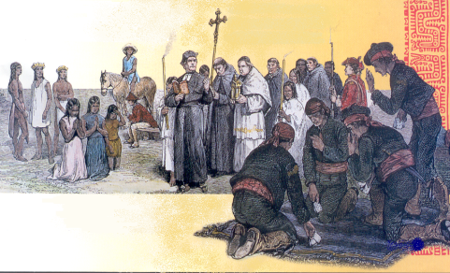

- Competition
In China, whether or not a fleet sailed was entirely up to the emperor and his advisors. But when Columbus looked for sponsors for his plan to sail across the Atlantic, he went from one royal court to another. The kings, queens, and royal officers who listened to Columbus’s proposal were eager to find a new route to Asia. However, the idea of sailing west across the Atlantic seemed far-fetched, and Columbus, had a hard time convincing people that his plan could work. Portugal, which came close to backing him at one point, thought that sailing around Africa was more promising. But the courts of Europe were fierce rivals. Once Columbus claimed the New World for Spain, all of them wanted to send out their own ships to explore the new lands for themselves.
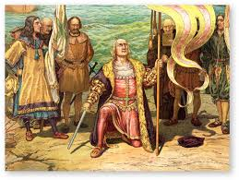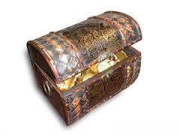
- Wealth
In 1453, the Ottoman Turks, who were Muslims, conquered Constantinople and renamed it Istanbul. Muslims now controlled all the known routes to Asia and could charge as much as they liked for the Asian spices and fabrics that were increasingly popular in Europe. These spices, including cinnamon, cloves, nutmeg, and pepper, were used by Europeans to improve the flavor of dried foods and disguise the taste of rancid food. They were grown naturally only in India, Sri Lanka, and in islands of what is now Indonesia. In the early 1400s, these spices were said to be worth their weight in gold. The country that could find a cheaper sea route to Asia would become immensely rich. This was the golden dream that sent the Portuguese around Africa.
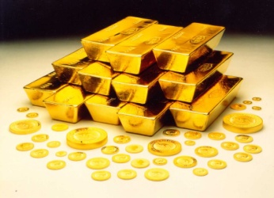
=
- Glory
While real nights set out across Europe on one campaign after another, poets in the castles of kings and queens were making up takes of legendary heroes on their own quests. From Spain to Germany, and from England to France, stories of King Arthur and Guinevere, of Roland, El Cid, and Siegfried were told and retold, and then set down in writing. These stories of great deeds, fearless men, and risk-filled journeys inspired explorers from the time of Columbus on. A captain sailing across the seas could easily picture himself as a knight on a heroic mission.

- Knowledge
In 1415, Prince Henry of Portugal was part of an army that captured the Muslim port of Ceuta in North Africa. While in the city, Henry got a sense of the great resources in gold and slaves that Africa held. Three years later, determined to learn everything he could about the continent, he established a “school” where explorers, sailors, mapmakers, and astronomers shared their knowledge. As each captain sailed father down the western coast of Africa, he reported back to the school, which made the next, longer, trip possible. Similarly, as soon as a captain returned from across the Atlantic, mapmakers scrambled to learn what he had found and to redraw their charts. Knowledge of the world was as precious as gold.

