The California Gold Rush by Robert K. Elder
Taken from The New York Times Upfront – upfrontmagazine.com
At first, James Wilson Marshall thought it was a trick of the light – perhaps the California sun shining on bits of quartz in the icy winter water. But the glint persisted as the young construction forearm walked near the American River close to the lumber mill he was building for businessman John Sutter in California. From the shallow mill trench his crew had carved next to the river, Marshall pulled out four or five shiny pebbles. He hammered one of the nuggets, changing its shape but not breaking it – a peculiar property of gold.
“I have found it!” Marshall exclaimed at the mill sit near Coloma, California.
Marshall’s discovery of gold on January 24th, 1848 would not only create new fortunes and cement the West as an American destination but also change the character of the developing United States. It brought prospectors, immigrants, and new technology to what would become known as the Golden State and fostered an entrepreneurial spirit that persists today.
“The gold rush was the first event in modern world history,” says historian H.W. Brands, author of The Age of Gold: The Californian Gold Rush and the New American Dream. “It was one of those events that had almost instantaneous effects on everyone on the continent.”
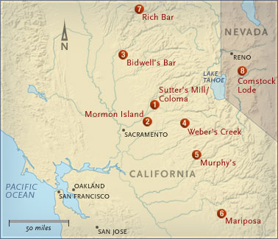
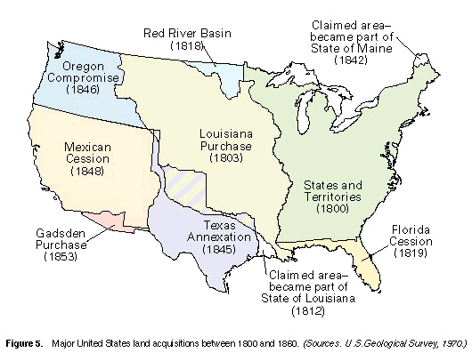
Before the discovery of gold in 1848, most of the West didn’t belong to the US. Many Americans believed it was the country’s “manifest destiny” to stretch from the Atlantic Ocean to the Pacific, and President James Polk (1845-1849) was determined to acquire the Oregon territory from Great Britain and California from Mexico. He secured Oregon through a series of treaties, but California was a lot tougher.
Mexico had already lost Texas, which was annexed as a US State in 1845. So Mexico was worried about what seemed a boundless American appetite for new land. Tensions resulted in the Mexican-American War (1846 – 48), which the US won. With the signing of the Treaty of Guadalupe Hidalgo on February 2nd, 1848 – nine days after the gold discovery at Sutter’s Mill – the US took ownership of what would become the states of Texas, California, Nevada, Utah; most part of New Mexico and Arizona; and parts of Colorado and Wyoming.
At the time, though, news traveled slowly: Neither the US nor Mexican governments knew about the gold in California. Word spread to the miners first, and they started arriving in the spring. By then, the media picked up the story.
Overnight Boomtown
The Californian newspaper wrote: “The whole country from San Francisco to Los Angeles, and from sea shore to the base of the Sierra Nevadas, resounds with the sordid cry of gold, GOLD, GOLD!” The newspaper’s editors then suspended publication so its staff could seek their fortunes. The next month, after running stories about whole towns abandoned because of gold fever, the California Star newspaper followed suit as its writers, editors, and printers rushed off.
President Polk officially announced the discovery in his State of the Union address in December 1848, spurring more migration to California. “Now that this fine province is a part of our country, all the States of the Union, some more immediately and directly than others, are deeply interested in the speedy development of its wealth and resources,” Polk said.
“All of the sudden, you could literally pick money up off the ground,” says Ed Allen, a historian and guide for Marshall Gold Discovery State Historic Park in Coloma. At the time when most people struggled to make $1 a day, gold prospectors “were picking up to $20 in gold per person per day,” Allen says. “As stories spread, people just couldn’t believe it at first. It just shook [them] to the core.”

Once it hit, gold fever attracted experienced miners from Latin America, laborers from China, investors from Europe, and speculators from Australia. Almost overnight, San Francisco was transformed from a tiny settlement of 1,000 in 1848 to a boomtown of 25,000 by the end of 1849 (the rush of gold prospectors eventually lent their nickname “the 49ers” to San Francisco’s NFL team).
The influx “internationalizes California quickly,” says historian Kevin Starr, author of California: A History. “
It’s a very polyglot (multilingual) experience.” For some, that growth came at a price. Native Americans in California, who Starr estimates numbered 150,000 in 1845, were subjected to attacks and lethal disease from outsiders. Five years later, their population was less than 30,000. Other culture clashes persisted. Miners faced not only dangerous journeys by land and sea, but also suspicion and racism, once they arrived in the mining camps.
“Within the year, [San Francisco] became the most cosmopolitan place on Earth,” says Brands. “Americans were not used to it. Until then, immigration had come from England, Northern Ireland, and Ireland, some from Germany. But pretty much, they all looked alike.”
Immigration Backlash
The Chinese, who by 1851 numbered 25,000 in California, were particularly exotic to Americans. The men wore braids, dressed in long robes, and spoke almost no English. Their customs, behaviors (including the use of opium), and diet were alien to Californians.
The competition for gold bred conflict and suspicion, which led to a number of anti-Chinese and anti-immigrant measures, most notably the $20 monthly Foreign Miners Tax. Later, the Chinese faced discrimination under the Chinese Exclusion Act of 1992, a federal law suspending Chinese immigration to the US for decades. Nevertheless, the Chinese persisted, and large numbers stayed to help build America’s railroad, embedding themselves in the fabric of the nation.
The most lasting fortunes were made not by the miners themselves nor the companies they worked for. Those who fared best provided goods and services to the mining industry. “They literally mined the miners,” historian Starr. Two such businessmen were Leland Stanford and Levi Strauss. Stanford and his brothers started a general store catering to miners, which led to investments in the Central Pacific Railroad and the governorship of California. Later, he founded Stanford University. Strauss, a Jewish immigrant from Germany who had lived in New York before moving to San Francisco, started as a dry goods peddler and in the 1870s, teamed with tailor Jacob Davis to produce denim work pants reinforced with copper rivets. Thus, Levi’s brand jeans were born.
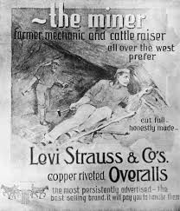
California’s success created a conundrum [problem] for the US, which was embroiled in a moral and political fight over slavery. The Gold Rush quickly legitimized California, raising the question of whether it would become a slave or free state. “Delegates meet in Monterey [in the fall of 1849], and they do not have the permission to form a state…and they write a constitution that outlaws slavery,” says Leonard Richards, author of The California Gold Rush and the Coming of the Civil War. “And with that, all hell breaks loose.”
The message was simple: If the rest of the country wanted its gold, California would join the union as a free state. This led to the Compromise of 1850 – a package of congressional bills that decided the fate of lands annexed after the Mexican – American War and quelled tensions between slave states and free states for a decade.
The gold rush continued till about 1852, with thousands of treasure seekers pouring into San Francisco. But by 1853, more people were leaving than were coming in, says Richard. “Before 1849, you had a real good chance of doing well. But in 1849, it’s estimated that 80,000 people showed up,” author Starr says. “The chances of becoming very wealthy were very slim. Only about 5 percent came home with profits.”
After boundaries were set in the Mexican- American war, the US came to resemble the 48 continental states (Alaska and Hawaii became states in 1959). In 1862, the Homestead Act brought more Americans to the West, with the promise of free land. And despite the bloody carnage of the Civil War, a transcontinental railroad was completed by 1869, enabling easier travel from east to west.
But beyond shaping the nation’s demography and geography, the discovery of gold in California rewrote the American DNA. “What California did was to legitimize failure,” says historian Brands. “Failure before, under the Puritan model, reflected the state of one’s soul. There was something not right with you.”
But after the Gold Rush, failure was just one of the costs doing business. As an American, you had license to reinvent yourself and embrace risk. “The West came to symbolize in the American imagination for many years to come…a fresh start where people can make it big,” whether in Hollywood or the tech world, says Brands. “It’s no coincidence that Silicon is just 100 miles from where gold was discovered.”

