Invention Advertisement

“If I had asked people what they wanted, they would have said faster horses.” –Henry Ford

“A lot of times people don’t know what they want until you show it to them.” –Steve Jobs

YOUR TASK:
-You will choose an invention from the list below, research your invention, and create an advertisement.

Inventions: Steam Engine, Telegraph, Sewing Machine,
First Airplane, Light bulb, Kodak Camera, Induction Electric Motor, Telephone, Fountain Pen, Cable Car, Steel, Elevator, Power Loom (Textile Industry), Spinning Jenny (Textile Industry)
Advertisement Must Include:

- Name of Invention (1)
- Slogan or Catchphrase (2)
- Description of how the invention works (4)
- Description of the target audience (2)
- Picture of the Invention (1)

10
Pts*

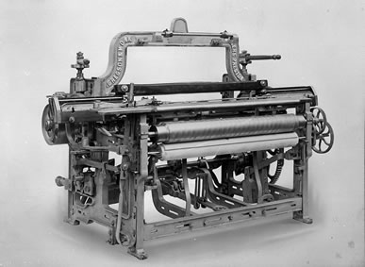
*Point values will be determined by the quality of the work, not simply the existence of the item.
In other words, each item must not simply be done, but done well.

