Name: __________________________________________________________ Period: _______

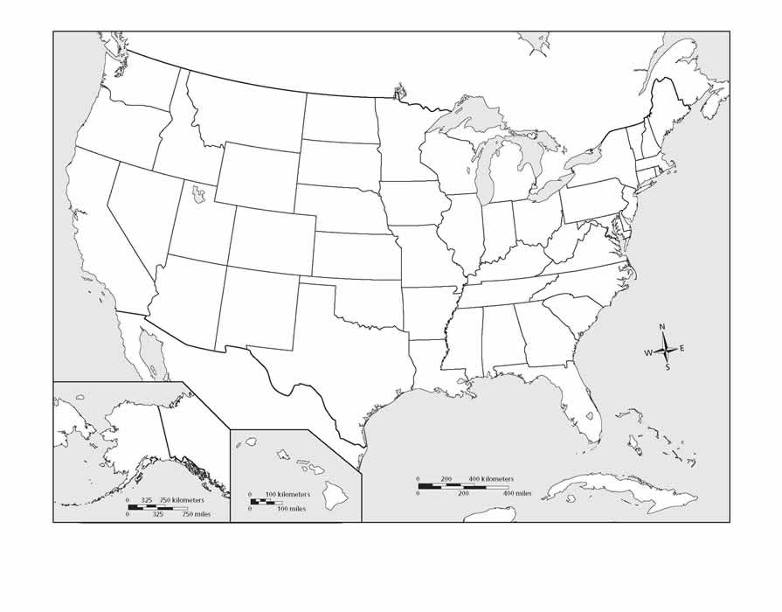
Identify and label the features at the left of the page. Don’t forget to create a legend and compass for your map!
United States
Countries:
Canada
Mexico

Cities:
New York
Philadelphia
Chicago
Houston
Boston
New Orleans
San Francisco
Washington, DC

Regions:
(Estimate the boundaries and color each region.)
Northeast
Southeast
Midwest
West
Southwest

Major Bodies of Water:
Atlantic Ocean
Pacific Ocean
Gulf of Mexico
Great Lakes

Major Rivers:
Mississippi
Missouri
Rio Grande

Mountains:
Rocky Mts.
Appalachian Mts.

Name: _____________________________________________________________ Period: _______

Use the maps in the back of the North Carolina textbook to identify and label the features at the left side of the page. Be sure to include a legend and compass for your map.

North Carolina
Regions:
(Estimate the boundaries and lightly color each region.)
Tidewater
Coastal Plain
Piedmont
Mountains

Fall Line:
Another geographic feature. Draw this line in red and label it.

States: Cities
Virginia Wilmington
Georgia Charlotte
Tennessee Raleigh
South Carolina Greensboro
Asheville
Large Bodies of Water:
Pamlico Sound
Albemarle Sound
Atlantic Ocean

Coastal Features:
Outer Banks
Cape Fear
Cape Lookout
Cape Hatteras
Roanoke Island

Rivers:
Estimate the path of each river and label it.
Cape Fear River
Neuse River

Mountains:
Appalachian Mts.

