Name: _________________________________________ Period: _______

Lewis and Clark- Great Journey West
Video Questions

- The narrator notes that Lewis and Clark (and many others) thought they might actually encounter Wooly Mammoths and other prehistoric creatures. What does this say about their perception of the territory to be explored?

Expedition to this new territory was equivalent to a journey to the moon today

- How old was Meriwether Lewis when he set out on the expedition? How old was William Clark? Lewis – 28
Clark - 32

- The video refers to the territory as “uncharted”. What does that mean? Who already lived there?
There were no maps or documented information/records; Native Americans

- How much did France sell the Louisiana territory to the United States for?
$15 million

- What were the expedition’s goals? What were they searching for?
To get all the way to the Pacific; they were searching for a North West Passage

- What river did the group follow on their journey?
Missouri River

- What were some of the challenges of navigating through the territory by boat?
Mosquitoes & ticks; barge in danger; sandbars; storms

- How did Lewis and Clark approach the natives that they found in the Great Plains?
They were ordered to be friendly; told that the Americans now claimed their land

- Which native group was the most powerful in the area that the group traveled? What happened on their first encounter?
Teton Sioux; they were surrounded by the Natives

- How old was Sacagawea when she met the expedition?
She was 16 years old

- What items did the group put together to send to President Jefferson in the spring?
A map drawn by Clark; what Lewis collected – new plant & animal species

- How did Sacagawea help the group?
Showed them edible plants & roots; saved important items when boat turned over

- What did the group have to do when they encountered the great falls in Montana?
The group had to walk 17 miles to go around the falls.

- After finding the source of the Missouri River, what did Lewis discover on the other side of the Continental Divide?
They saw tall mountains covered in snow.

- What made the mountain crossing so dangerous/treacherous?
There was ice/snow. They were traveling on foot, and they had few supplies.

- How long did the return trip take?
The return trip took 6 months.

- How many members of the expedition died on the journey?
One man died on the journey.

Now that you’ve watched the video, answer the following questions with thorough, specific responses.
- Did the expedition accomplish its goals? Why or why not?

- Do you think the expedition of Lewis and Clark was necessary following the purchase of the Louisiana territory? Why or why not?

- Summarize the role of the Native American tribes in the expedition of Lewis and Clark. In your opinion, would they have survived without the natives they encountered?
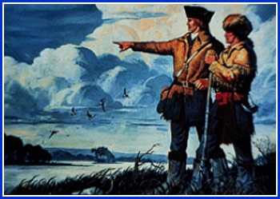
Based on what you’ve learned about Lewis and Clark, write a caption for this painting.

