Name: _________________________________________ Period: ________

Westward Expansion of the United States

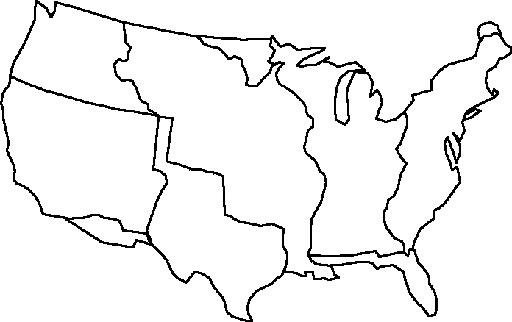
Instructions
1. Label the United States according to how and when the different parts were acquired, using the map provided. Include all essential information (name of area, how it was gained, year).
2. Include the path of Lewis and Clark.
Now move on to the back!

Mapping the Growth of the United States During the 1800s

- Approximately how much larger did the United States become as a result of the Louisiana Purchase?

- Name any five modern states that were part of each of the territories below: (Use a political map if needed.)
Original 13 Colonies | Louisiana Purchase | Texas Annexation | Mexican Cession

3. List two territories from your map according to how they were acquired.
Gained Peacefully  (Purchased) | Gained By Force  (War Gains)
1.

2.

4. What parts of our country did we gain from each of the following European countries?
Part of the first one has been completed for you.
Great Britain | France | Spain | Mexico
East coast of the United States, excluding Florida

5. What was the last small piece of the contiguous United States to be acquired?

6. Looking Ahead- How do you think Native Americans were impacted by the growth of the United States at this time?
