Name: _______________KEY__________________________ Period: ________

Westward Expansion of the United States

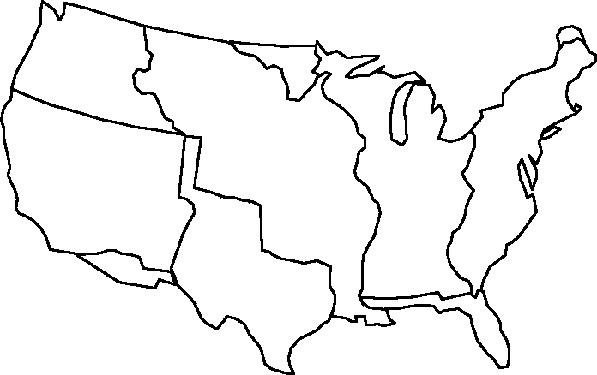
Webster-Ashburton Treaty (from England 1842)
Ceded by England (1818)
Original 13 Colonies
Florida Cession (from Spain 1819)
From England, Treaty of Paris 1783
Texas Annexation (independent republic 1845)
Louisiana Purchase (from France 1803)
Gadsden Purchase (from Mexico 1853)
Mexican Cession (from Mexico 1848)
Oregon Country (from England 1846)
Instructions
1. Label the United States according to how and when the different parts were acquired, using the map provided. Include all essential information (name of area, how it was gained, year).
2. Include the path of Lewis and Clark.
Now move on to the back!

Mapping the Growth of the United States During the 1800s

- Approximately how much larger did the United States become as a result of the Louisiana Purchase?
The United States doubled in size as a result of the Louisiana Purchase.

- Name any five modern states that were part of each of the territories below: (Use a political map if needed.)
Original 13 Colonies | Louisiana Purchase | Texas Annexation | Mexican Cession
NY, NJ, DE, NC, SC, GA, VA, MD, CT, RI, PA, MA, NH | LA, OK, KS, MO, AK, IA, NE, SD, ND, MN, MT | TX, NM, OK, CO, KS | NM, UT, CO, WY, CA, AZ, NV

3. List two territories from your map according to how they were acquired.
Gained Peacefully  (Purchased) | Gained By Force  (War Gains)
Gadsden Purchase, Oregon Country, Louisiana Purchase, Texas Annexation*, Webster – Ashburton Treaty, Florida Cession* | Mexican Cession, 13 Colonies/Treaty of Paris, Texas Annexation*, Florida Cession*

4. What parts of our country did we gain from each of the following European countries?
Part of the first one has been completed for you.
Great Britain | France | Spain | Mexico
East coast of the United States, excluding Florida  Northwest (Oregon Territory),  Tip of Maine/Part of Minnesota (Webster-Ashburton) | Middle of the United States (Louisiana Purchase) | Florida Cession | Southwest (Texas Annexation, Mexican Cession, Gadsden Purchase)

5. What was the last small piece of the contiguous United States to be acquired?
Gadsden Purchase

6. Looking Ahead- How do you think Native Americans were impacted by the growth of the United States at this time?
Answers will vary
