The Strategic Choices of the North and South
Excerpt from Robert E. Lee’s Civil War, by Bevin Alexander, pages 7-9

Confederate President Davis put his faith in the importance of "King Cotton" to the immense textile industries of Britain and the continent. He believed the major European powers would intervene, force the North to accept Southern independence, and thereby save their economies. The South merely had to hold out until cotton stocks ran out at European mills. However, Europe learned quickly to do without Southern cotton, and Davis had to face the fact that he had staked the South's fortunes on this fiber and had lost.
To defeat the South, General [Winfield] Scott proposed the "Anaconda Plan": capture New Orleans and other Southern ports, seize the Mississippi River and cut off the Confederate states west of the river, and threaten Richmond, thereby containing Confederate forces east of the Allegheny Mountains. In this way, Scott believed, the South would be denied foreign arms, and its resistance would ultimately be squeezed to death, just as an anaconda snake squeezes its victims lifeless.
This was a good strategy, and Lincoln belatedly adopted it. However, it lacked a decisive offensive element to stamp out resistance in the event the Confederacy refused to quit. The answer was to seize Chattanooga, Tennessee, and Atlanta, Georgia, through which ran the main lateral railways of the Confederacy.
Davis should have recognized that the strategic frontier of the Confederacy ran from the Potomac River at Washington, along the Alleghenies to Chattanooga, thence along the Tennessee River, crossing the Mississippi around Memphis, then to Little Rock on the Arkansas River. Kentucky, Missouri, and Tennessee were only advanced posts that could not be defended permanently.
The solution was to base the South's main force on Chattanooga, with another strong army in Virginia. A vigorous defensive war in Tennessee would have protected the supplies of Mississippi, Alabama, and Georgia, kept open the railroads linking the entire strategical region with the Atlantic and Gulf ports, preserved crossings into Arkansas and Louisiana, and presented a constant threat to Kentucky and the main Union supply line leading back to Louisville. On the other hand, if Chattanooga-Atlanta were lost, the Confederacy in effect would be reduced to the Carolinas and Virginia.
Lincoln only insisted on the Chattanooga plan late in the war. Until then, both sides pursued vague, confused, and indecisive strategies west of the Appalachian Mountain chain. Davis saw the importance of Chattanooga too late, and he never insisted on positioning most Confederate strength to protect it.
Both sides instead riveted their attention and most of their strength on the Virginia theater and guarding their political capitals, Washington and Richmond. Consequently, the Confederate victory at Manassas on July 21, 1861, froze Union activity until Lincoln could find some way to end the impasse, and get Federal troops marching on Richmond again.
History 110 - The Civil War: Goals, Strategies, and Consequences

#1: Goals of the Union and Confederacy on the eve of the Civil War

In one respect, the Union and Confederacy had the same goal - to preserve a way of life. But all similarities ended there - because both sides wanted a different way of life preserved.

Confederacy - Its goal was to secure independence from the North and to establish an independent nation free from Northern political oppression and the repression of slavery. The War from beginning to end would be a noble crusade for democracy for white people.
- This goal was grounded firmly in the belief that the Constitution protected slavery, but the Union had denied that right. Southerners, therefore, had the right to secede as it was the only way to defend their right to own slaves and their belief in states' rights.
- Their actions, therefore, were defensive as they had no choice but secession because of the oppressive politics of the North
Union - Its initial goal was to reconcile the Union, while its mid-war goal became to reunite states under a Union in which slavery was not tolerated. The war from beginning to end would be a noble crusade for democracy for all people, not just in America, but throughout the world.
- This goal was grounded firmly in the belief that the South had no right to secede from the Union and that secession was treasonous and paramount to an act of war against the Union.
- Their actions, therefore, were defensive as they had no choice but to call for troops after the firing of Fort Sumter.
As the war continued, the Confederacy's goals remained the same - BUT the Union's goal changed.
- When it became clear to Lincoln that the North might lose the war and would only win with great difficulty, it became necessary to change the reason for fighting.
- Freeing the slaves became that reason. Thus, the new Union goal was to retain and reshape the Union - by reuniting the states under a union that no longer tolerated slavery!
#2: Initial political strategies of the Union and Confederacy

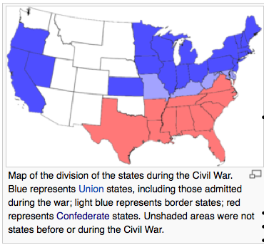
Union Goals. The union initially adopted four strategies:
- Invade the Confederacy and destroy its will to resist.
- Obtain the loyalty of the border states - Maryland, Delaware, Kentucky, Missouri, in 1863, West Virginia. This was absolutely essential for several reasons:
  - The border states had 2/3 of the South's entire white population, 3/4 of the South's industrial production, and over half of all its food and fuel.
  - After Fort Sumter, the northern-tier of the slaveholding states were still undecided about whether to secede - Maryland, Delaware, Kentucky, Missouri. Eventually, all four decided to stay in the Union, but pro-Confederate sympathizers existed in each state and men fought for the Confederacy in all four.
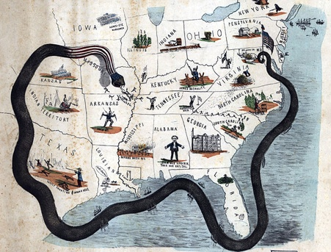
- Construct and maintain a naval blockade of 3,500 miles of Confederate coastline.
- Prevent European powers - especially Great Britain and France - from extending recognition of and giving assistance to the Confederacy. Lincoln knew he was in a bind as long as the Confederacy portrayed their rebellion as one for national self-determination. He also knew that if he could redefine the war as a struggle over slavery, Europe’s sympathies would no longer lay with the Confederacy. However, he was not able to address these concerns until mid-way through the war.

Confederacy Goals: To be victorious, knew it did not need to invade the North or capture a mile of its territory. Its strategies were fairly simple:
1. Defend Confederate land.
2. Prevent the North from destroying the Confederate army.
3. Break the Union's will to fight.

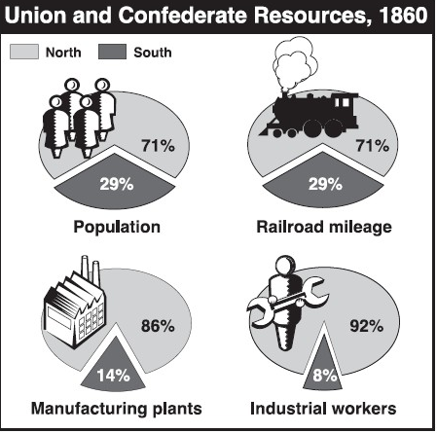
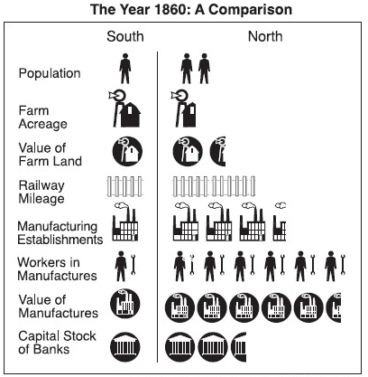
#3: Resources of the Union and Confederacy at the beginning of the war

- Total population:
  - Union: 22,300,000; white males = 4,600,000
  - Confederacy: 9,100,000; white males = 1, 100,000
  - Union Advantage: 2.5 to 1; white males = 4.2 to 1
- Value manufactured goods:
  - Union: $1,730,000,000
  - Confederacy: $156,000,000
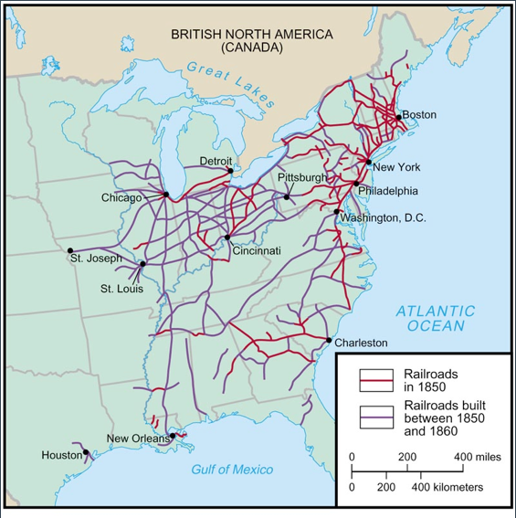
  - Union Advantage: 11 to 1
- Railroad mileage
  - Union: 22,000
  - Confederacy: 9,000
  - Union Advantage: 2.4 to 1
- Coal production (in tons)
  - Union: 13,680,000
  - Confederacy: 650,000
  - Union Advantage: 21 to 1
- Corn/wheat production (bushels)
  - Union: 698,000,000
  - Confederacy: 314,000,000
  - Union Advantage: 2.2 to 1
- Draft animals
  - Union: 5,800,000
  - Confederacy: 2,900,000
  - Union Advantage: 2 to 1
- Cotton production (bales)
  - Union: 43,000
  - Confederacy: 5,344,000
  - Confederacy Advantage: 1 to 124

#4: North and South Advantages at the Start of the Civil War

Military
Union | Confederacy
Had army, navy, and experienced government | Despite the North’s larger population, the South had an army almost equal in size during the first year of war
Controlled the Navy, and could blockade southern ports (*ingredients for gunpowder were imported) | Had many of the best military leaders

Southern Advantages
Agricultural Advantage: could produce all the food it needed (transporting it was difficult)

Trained Officer Advantage: 7 of the 8 military colleges in the country were in the South

Homefield Advantage: South defending their own (familiar) territory

Morale: Fighting for a war of ideals- independence, state’s rights

Experience: More experience riding horses and firing weapons

