Name __________________________________________________________________________ Period ____________
The Development of Political Parties
Republican Party
(not the same as today’s Republican Party)
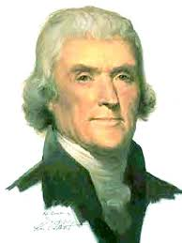
Based on Thomas Jefferson’s Views

Federalist Party

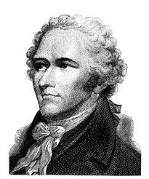
Based on Alexander Hamilton’s Views

By the election year of 1792, Hamilton & Jefferson headed rival political parties to enact their views.
Both parties had the same goal, a free republic, but differed in the ways to attain it.

“Jefferson said ‘the many!’ Hamilton said ‘the few!’ Like opposite sides of a penny were those exalted two. If Jefferson said, ‘It’s black, sir!’ Hamilton cried, ‘It’s white!’ But ‘twixt the two, our Constitution started working right.”
- Stephan Vincent Benet

Federalist vs. Republicans
Use the textbook page 291 to fill in the chart below
Political Party | Republican | Federalist
Leaders | Thomas Jefferson | Alexander Hamilton
Who Should Have Most Power

Type of Government

Economy

Interpretation of Constitution

Foreign Relations

National Bank

Protective Tariffs

John Adams’ Presidency (1797 – 1801)
Read textbook pages 298 – 301 and answer the following questions.
Trouble With France/The XYZ Affair
- What caused the tension between the United States & the French?

- What was the XYZ Affair?

- How did Adams settle differences with France?

Alien & Sedition Acts
- What two groups did the Alien & Sedition Acts target?

- What did the Alien Act increase?

- What did the Sedition Act limit?

- Why did the states want to nullify the Alien & Sedition Acts?

