Post-World War II America:
1950s America, Civil Rights and the Cold War
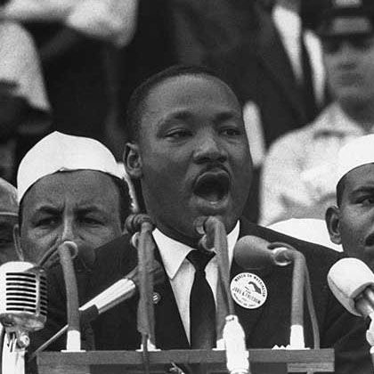
In this unit, I will learn:
- About the changes that took place in American culture during the 1950s.
- How the roles of women changed after WWII.
- About the rise of suburbs and modern conveniences.
- How “teenagers” became an important group during this time.
- What life was like for people living in the Jim Crow south?
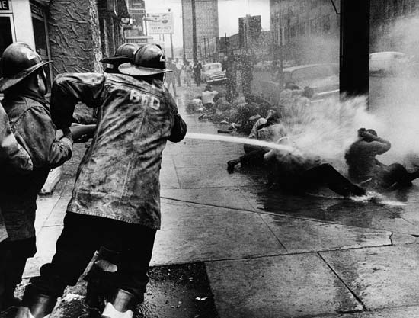
- About how major Supreme Court cases affected the Civil Rights Movement.
- About the major moments in the Civil Rights movement.
- About different forms of protest and key leaders driving this movement for change.
- How the US got into a “Cold War” with the Soviet Union after WWII.
- How the US competed with the Soviet Union in terms of a Space Race and Arms Race.
- About the Korean War and how it ended (but not really).
- About the escalation of the Vietnam War and the response of the American people over time.

UNIT CALENDAR*
16  Post WWII America  Discovery Ed Video – Escape from Berlin | 17  Key Terms  Cold War ppt. w/ Notes | 18  Jim Crow South | 19  Civil Rights Supreme Court Cases: Plessy & Brown | 20  Civil Rights Movement
23  Test - Cold War, 1950s, and Civil Rights | 24  Korean War | 25  Vietnam War | 26  Science EOG  Billy Joel Intro | 26  Science EOG  Continue Billy Joel
30  No School  Memorial Day | 31  English EOG  Billy Joel Verse/Research | 1  Math 8 EOG  Billy Joel Verse/Research | 2  CCMI EOC  Billy Joel Verse/Research | 3  CCMI EOC  Verse Presentations  8th Grade Dance
6  CCMI EOC  Awards Practice – 7th Period | 7  8th Grade Awards Ceremony | 8  Current Events | 9  Last Day of School  8th Grade Picnic | Have a wonderful summer break!  You will be missed!
*This is a rough outline. We will adjust daily activities as needed.

Key Terms

Baby Boom | A marked increase in the birthrate after World War II. On average, a baby was born every 10 seconds.
suburbs | Residential area on the outskirts of a city or town, these grew dramatically after WWII as more people wanted to settle down with their families away from large cities. Enormous subdivisions like Levittown started popping up across the country (see picture on reverse).
interstate highway system | Primarily the brainchild of President Eisenhower, this is a network of major highways that span the country from coast to coast and allows for ease of travel across the United States.
Jim Crow Laws | State laws that discriminated against African Americans. Examples included segregated facilities, prohibiting interracial marriage, etc.
Civil Rights Act | Passed by President Johnson in 1964, it outlawed major forms of discrimination in the United States based on race, color, religion, sex, or national origin.
Voting Rights Act | Passed in 1965, outlawed voting practices such as poll taxes and literacy tests which were designed to limit voting rights of African Americans
Cold War | A conflict between the US and Soviet Union that began shortly after WWII and lasted until the fall of the Berlin Wall in 1989
Arms Race | A competition between the US and Soviet Union in the production of nuclear weapons following WWII
Space Race | A competition between the US and Soviet Union in the 1950s to capture various “firsts” in space exploration (first man to orbit the Earth, first man on moon, etc)
Vietcong | The name of the communist North Vietnamese forces that the US fought against in the Vietnam War. They were extremely adept at guerilla fighting tactics.
demilitarized zone | A strip of land that separates North and South Korea in which military forces are forbidden. It remains uninhabited today.
Agent Orange | A chemical defoliant used to destroy the jungle canopy of Vietnam to better locate the Vietcong.

