Name: __________________________________________ Period: _______

WWII On the Homefront: Political Cartoons and Propaganda

Theodore Geisel (“Dr. Seuss”) created over 400 political cartoons during WWII. Briefly describe the purpose of each cartoon below.

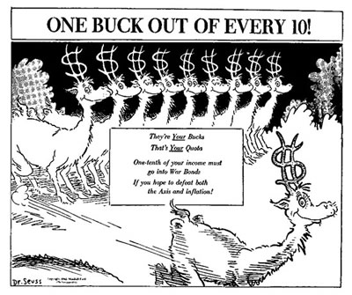

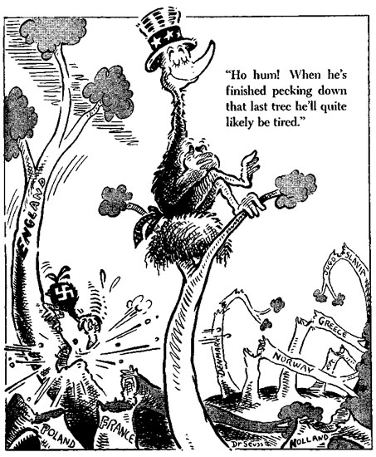

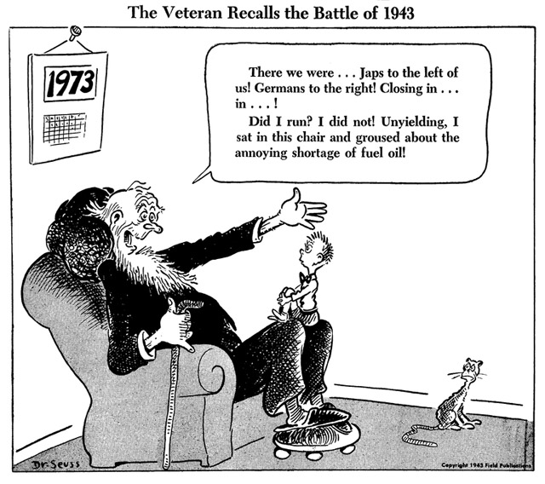
What does it mean? What is it encouraging Americans to do?
What does it mean? What is it encouraging Americans to do?
What does it mean? What is it encouraging Americans to do?
The Power of Persuasion: Propaganda

Briefly describe each of the three different methods of propaganda below.
ETHOS | PATHOS | LOGOS

Now, evaluate three propaganda posters from WWII by completing the analysis below.
- Describe the poster. (Images, color, words)

- Purpose: Audience:

- What technique was used by the author of this poster? EXPLAIN your choice, citing SPECIFIC examples from the poster and including any context from the war that may be necessary.

- Do you think this poster was effective at the time? Why or why not?

- Describe the poster. (Images, color, words)

- Purpose: Audience:

- What technique was used by the author of this poster? EXPLAIN your choice, citing SPECIFIC examples from the poster and including any context from the war that may be necessary.

- Do you think this poster was effective at the time? Why or why not?

- Describe the poster. (Images, color, words)

- Purpose: Audience:

- What technique was used by the author of this poster? EXPLAIN your choice, citing SPECIFIC examples from the poster and including any context from the war that may be necessary.

- Do you think this poster was effective at the time? Why or why not?

