Slavery in the United States

A BRIEF HISTORY
CIVIL WAR TRUST
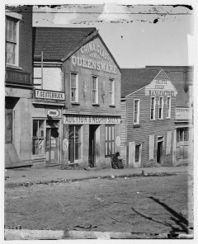
The slave market in Atlanta, Georgia, 1864 (Library of Congress)
When the North American continent was first colonized by Europeans, the land was vast, the work was harsh, and there was a severe shortage of labor. Men and women were needed to work the land. White bond servants, paying their passage across the ocean from Europe through indentured labor, eased but did not solve the problem. Early in the seventeenth century, a Dutch ship loaded with African slaves introduced a solution—and a new problem—to the New World. Slaves were most economical on large farms where labor-intensive cash crops, such as tobacco, could be grown.
By the end of the American Revolution, slavery had proven unprofitable in the North and was dying out. Even in the South the institution was becoming less useful to farmers as tobacco prices fluctuated and began to drop. However, in 1793 Northerner Eli Whitney invented the cotton gin; this device made it possible for textile mills to use the type of cotton most easily grown in the South.
Cotton replaced tobacco as the South’s main cash crop and slavery became profitable again. Although most Southerners owned no slaves at all, by 1860 the South’s “peculiar institution” was inextricably tied to the region’s economy.
Torn between the economic benefits of slavery and the moral and constitutional issues it raised, white Southerners grew more and more defensive of the institution. They argued that black people, like children, were incapable of caring for themselves and that slavery was a benevolent institution that kept them fed, clothed, and occupied. Most Northerners did not doubt that black people were inferior to whites, but they did doubt the benevolence of slavery. The voices of Northern abolitionists, such as Boston editor and publisher William Lloyd Garrison, became increasingly violent. Educated blacks such as escaped-slave Frederick Douglass wrote eloquent and heartfelt attacks on the institution.
The Underground Railroad was organized to help slaves escape north to freedom. Uncle Tom’s Cabin, written in 1852 by Harriet Beecher Stowe, refuted the Southern myth that blacks were happy as slaves.
In reality, treatment of slaves ranged from mild and paternalistic to cruel and sadistic. Husbands, wives, and children were frequently sold away from one another and punishment by whipping was not unusual. The United States Supreme Court in the 1857 Dred Scott Decision ruled that slaves were subhuman property with no rights of citizenship. They had no legal means of protesting the way they were treated. Southerners feared open rebellion but this was rare. However, slaves would pretend illness, organize slowdowns, sabotage farm machinery, and sometimes commit arson or murder. Running away, usually for short periods of time, was common.
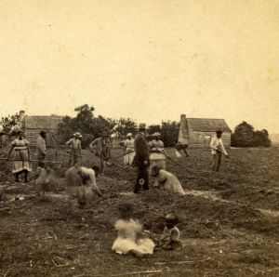
Slaves work in Sea Islands, South Carolina. (Library of Congress)
The outbreak of the Civil War forever changed the future of the American nation. The war began as a struggle to preserve the Union, not a struggle to free the slaves, but many in the North and South felt that the conflict would ultimately decide both issues. Many slaves escaped to the North in the early years of the war, and several Union generals established abolitionist policies in the land Southern land that they conquered. Congress passed laws permitting the seizure of slaves from the property of rebellious Southerners. On September 22, 1862, following the dramatic Union victory at Antietam, President Abraham Lincoln presented the Preliminary Emancipation Proclamation.
This document decreed that, by the power of the United States armed forces, all slaves in states that were still in rebellion one hundred days after September 22 would be "thenceforward and forever free." Furthermore, Lincoln established an institution through which blacks could join the U.S. Army, an unprecedented level of integration at that time. The United States Colored Troops (USCT) served on many battlefields, won numerous Medals of Honor, and ensured eventual Union victory in the war.
On December 6, 1865, eight months after the end of the Civil War, the United States adopted the 13th Amendment to the Constitution, which outlawed the practice of slavery.
—Sources: Historical Times Illustrated Encyclopedia of the Civil War edited by Patricia L. Faust (Harper Perennial, 1991), Encyclopedia of the Civil War edited by John S. Bowman (Dorset Press, 1992), and The American Heritage Picture History of the Civil War by Bruce Catton (Bonanza Books, 1982).
Want the Latest? Follow us on Twitter and Facebook:

