Unit 2 – The Colonial Era
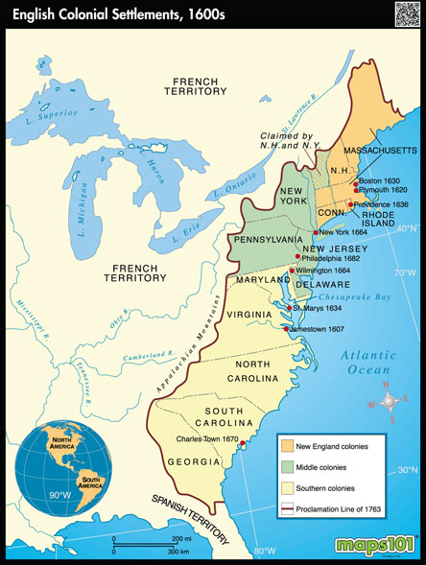
By the End of this Unit, I will be able to:
- Write a paragraph using each key term in context.
- Describe the struggles faced by Jamestown settlers.
- Describe life in Plymouth.
- Describe life in Massachusetts Bay.
- Describe characteristics unique to the New England Colonies.
- Describe characteristics unique to the Middle Colonies.
- Describe characteristics unique to the Southern Colonies.
- Label a map with the names of the 13 English colonies, and name the region each colony belongs to (New England, Middle, and Southern regions).

UNIT CALENDAR*
14  Colony Simulation | 15  Colony Simulation | 16  Colony Simulation | 17  Constitution Day – Preamble Activity | 18  Colony Simulation Assessment – Written Reflection
21  Unit 2 – Colonial Era Overview &  Key Terms  Jamestown During the Starving Time  Jamestown After the Starving Time | 22  Nightmare in Jamestown Video with questions | 23  Teacher Work Day | 24  Jamestown/  Plymouth/  Mass. Bay Notes  Map of 13 Colonies | 25  Colonial Region ppt. and graphic organizer  Assign Acrostic Poem
28  Review 13 Colonies Map  Work on Acrostic | 29  Acrostic Poem Due  Review for tomorrow’s test | 30  Colonial Era Unit Test
*This is a rough outline. We will adjust daily activities as needed.
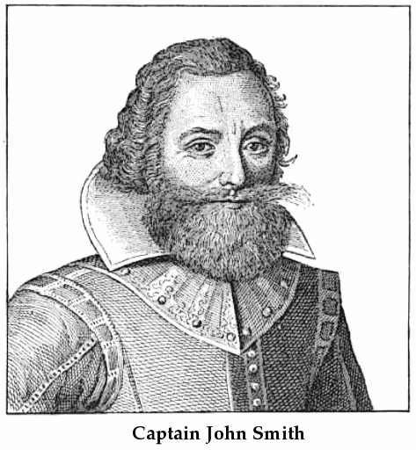
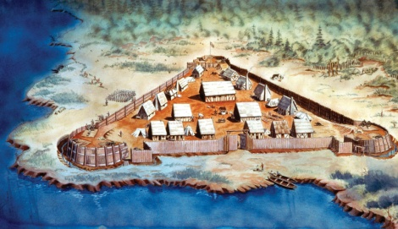
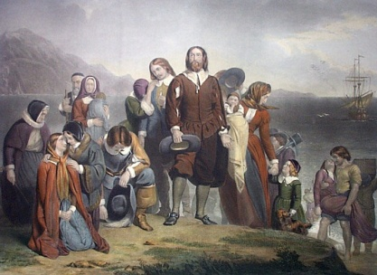

Key Terms

Term | Definition
Puritan | someone who wanted to "purify" (reform/change) the Church of England and were driven out of their home. Many colonized Massachusetts for Religious freedom
Separatist | someone who wanted to split (separate) from the official Church of England
Pilgrim | a person who takes an especially long journey for religious reasons
persecute | to mistreat due to one's religion, race, or political beliefs
charter | a contract granted by the king to individuals or groups who were to be in charge of settlement and then govern the settlers
colony | a group of people who settle in a distant land, but who are still under the rule of their native land
Mayflower Compact | a document created by the Pilgrims that allowed for self-government and a lawmaking body of elected officials
indentured servant | person who signs a contract to work for a set number of years in exchange for ocean passage to the colonies

Key People:
William Bradford
John Winthrop
John Smith
Powhatan
Pocahontas
First Permanent English Settlements:
Jamestown
Plymouth
Massachusetts Bay Colony

Colonial Regions:
Middle Colonies
New England Colonies
Southern Colonies
Squanto

