**Unit 3 – The American Revolution**

**MCj01498460000[1]**

**By the End of this Unit, I will be able to:**

* describe how the result of the French and Indian War affected the economy of Great Britain and the 13 Colonies.
* identify the different ways that the colonists resisted British rule.
* explain how the Intolerable Acts ultimately led to the beginning of the Revolutionary War.
* identify the political reasons why the colonists wanted independence from Great Britain.
* describe the three parts of the Declaration of Independence.
* identify ways in which the Declaration of Independence ignited the Americans to want independence from Great Britain.
* explain how leaders and citizens contributed to the outcome of the American Revolution.
* explain the reasons why the Articles of Confederation weakened the newly formed United States.
* identify the democratic principles written in the Articles of Confederation.
* identify the differences and similarities between the Articles of Confederation and the Constitution.
* explain how compromises shaped the framework of the Constitution.

**UNIT CALENDAR\***

|  |  |  |  |  |
| --- | --- | --- | --- | --- |
| 28 | 29 | 30 | 1  Unit 3 Overview/  Key Terms  French & Indian War | 2  Causes of the Revolution Notes |
| 5  Finish Causes Notes | 6  Causes Music Activity | 7  Causes/Key Term Test  State Flag | 8  Dec. of Independence | 9  Explore Test? |
| 12  Battles/Timeline | 13  Battles/Timeline Cont. | 14  America Video | 15  Key People of the American Revolution | 16  Early Release  **Career Day-**  **No Classes** |
| 19  End of War and Wrap Up | 20  Review Day | 21  Unit Test:  American Revolution | 22  National Treasure | 23  National Treasure |

**C:\Documents and Settings\mdyer2\Local Settings\Temporary Internet Files\Content.IE5\80U1V9Q2\MC900149883[1].wmf***C:\Documents and Settings\mdyer2\Local Settings\Temporary Internet Files\Content.IE5\43Y38JXT\MC900149426[1].wmf*This is a rough outline. We will adjust daily activities as needed.*

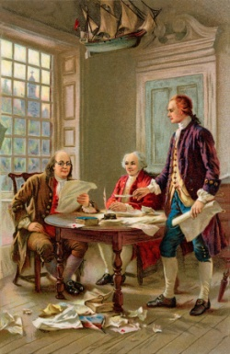

**Unit 3, The American Revolution – Key Terms**

|  |  |
| --- | --- |
| Treaty of Paris 1763 |  |
| boycott |  |
| delegate |  |
| repeal |  |
| tyranny |  |
| compromise |  |
| treason |  |
| unalienable |  |
| Continental Congress |  |
| Loyalists |  |
| Minutemen |  |
| Patriots |  |
| Treaty of Paris 1783 |  |