Name__________________________________________ Unit 6 overview – Civil War

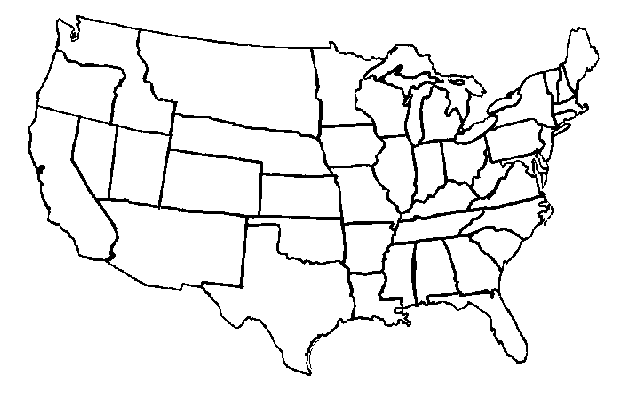

What is a border state? ____________________________________________________

____________________________________________________

List the 5 border states: ____________________________________________________

____________________________________________________

Use pg 513 to label the map. Label the state names and color code the states. Do not fill in the territories. Highlight the border of the Confederate States of America.

Union states 

Confederate states