World War II
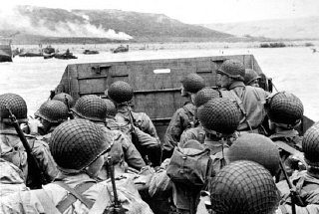
In this unit, I will learn:
- How and why dictators came to power in Europe and Japan.
- How and why Japan attacked the US Naval Base at Pearl Harbor.
- How the US responded to the attack at Pearl Harbor.
- Why German U-Boats patrolled the coast of North Carolina early in the war.
- How citizens participated in the war on the Homefront.
- How families used ration points.
- How countries used propaganda to influence their people.
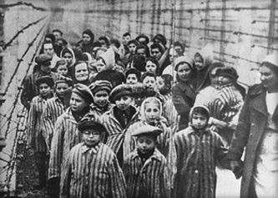
- How and why the US used the Navajo to create a military code.
- How and why the allies attacked Nazi territory on D-Day.
- The general chain of events known as the Holocaust.
- The various ways that people fought back and resistance efforts during the Holocaust.
- How the war ended (twice!).
- About Truman’s alternatives to dropping the atomic bombs on Japan.
- What the experience was like for a survivor of Hiroshima.

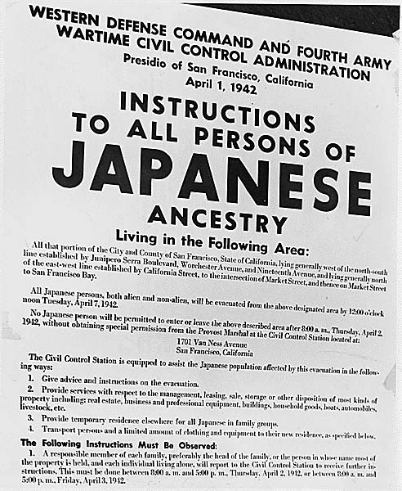
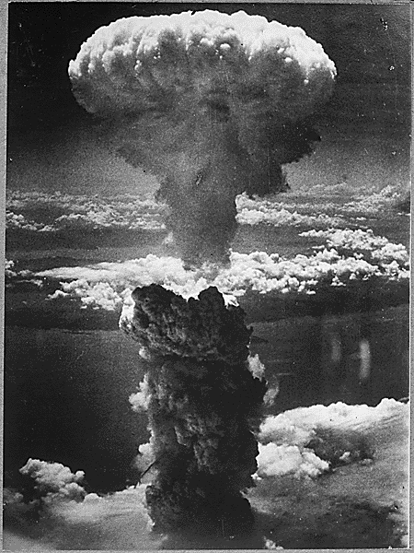
UNIT CALENDAR*
4  Cinderella Man Great Depression Clips | 5  WWII Overview & Key Terms  For Real or No Way | 6  Leaders of WWII  Key Term Assignment | 7  WWII Causes PPT and Notes | 8  Torpedo Junction  Battleship Game
11  WWII On the Homefront & Rationing | 12  WWII Causes and Key Terms Test  Rationing Assignment | 13  Tuskegee Airmen | 14  WWII Propaganda & Political Cartoons | 15  WWII: The World at War Video
18  Navajo Code Talkers &  Decoding Activity | 19  D-Day | 20  Holocaust  Overview Notes | 21  Holocaust  Resistance and Survivor Stories | 22  Dropping the Bomb/Ending the War PPT
25  What Should Truman Do? | 26  Contrasting Views on Pearl Harbor/Hiroshima | 27  BBC Documentary - Hiroshima | 28  BBC Documentary - Hiroshima | 29  Tuskegee Airmen Floating Day – Guest Speaker
2  Review | 3  WWII Unit Test | 4  America Video:  WWII
*This is a rough outline. We will adjust daily activities as needed.

Key Terms

Axis Powers | Germany, Italy, and Japan; these countries signed a pact in Berlin in 1940
Allied Powers

dictator

fascism

Nazi Party

blitzkrieg

anti-Semitism

appeasement

internment camps

The Holocaust

Kamikaze pilots

D Day

United Nations

“Torpedo Junction”

Manhattan Project

V-E Day

V-J Day

